Table of Contents

1 INTRODUCTION: 2

2 AIM: 2

3 THEORY: 2

4 EQUIPMENT AND SPECIFICATION: 4

5 OBSERVATION TABLE: 6

6 ARRANGEMENTS: 6

7 GRAPHS: 7

8 COMPARISION WITH THE THEORY: 8

9 CONCLUSION AND DISCUSSION: 8

10 ADDITIONAL DISCUSSION: 9

# INTRODUCTION:

In this laboratory session, the value of the mass force and mass moment is observed by using TM-180 model.

# AIM:

To optimize the balancing of a four-cylinder reciprocating engine by analyzing free mass forces and mass moments under various configurations of the TM-180 model.

# THEORY:

**Reciprocating Engine**

A reciprocating engine is an internal combustion engine that uses pistons in cylinders to convert fuel combustion pressure into mechanical work, turning linear motion into rotational motion via a crankshaft. It operates in four strokes: intake, compression, power, and exhaust. These engines vary by configuration, number of strokes, and fuel type. Cylinder count and crank offset significantly impact their vibration behaviour.

**TM-180 Model**

The model examines mass forces and moments in reciprocating engines, including 1, 2, and 4-cylinder in-line engines. The ratio of rotating to oscillating masses is adjustable by adding weight to the piston. Electric signals from the model are shown on an oscilloscope, enabling Fourier analysis for 1st and 2nd order ratios. The model has a sturdy suspension, requiring no extra measuring devices. Crank realignment uses 4 mm pin markings. Six configurations include 4-cylinder (flat/3-D, symmetrical/ asymmetrical), 2-cylinder 180° twin, and 1-cylinder parallel twin. Maintenance is minimal, involving cylinder cleaning and re-tensioning the toothed belt as speed increases.

**Types of Forces in Reciprocating Engine**

The internal forces cause vibrations and oscillations, along with external effects. Based on their origin, there are two types: gas force and mass force.

**Gas Force**

The gas force in a reciprocating engine results from pressurized gas in the cylinder, cover, and piston, transferring energy to the crankshaft. These internal forces are absorbed by the engine and not expelled, with the energy being widely used in industries.

**Mass Force**

Mass force in reciprocating engines is caused by the acceleration of moving masses, leading to periodic vibrations. These forces are classified into centrifugal force from rotating masses and oscillatory force from oscillating masses. Compensating masses can eliminate these forces, depending on the engine design (cylinder number and orientation). Adjusting crank orientations can reduce forces, but different planes of force create moments.

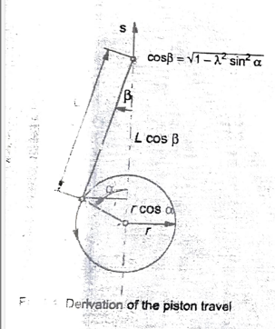**Kinematics**

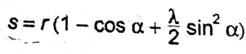The piston travel can be represented by power series approximation as:

The piston speed and acceleration are calculated by single and double

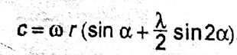differentiation over time, with constant angular velocity ω.

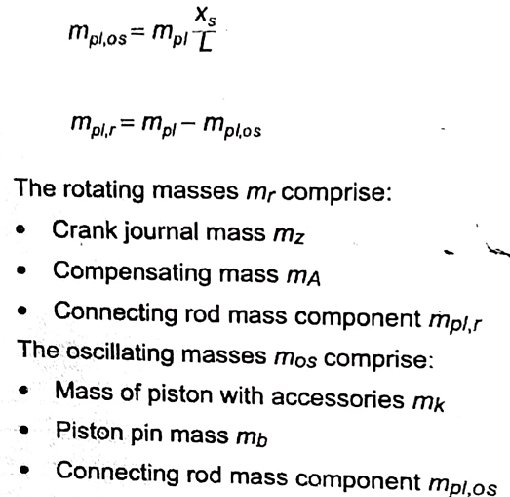The mass force arises from mass and acceleration. The connecting rod's lifting and rotating motion divides the total mass into rotating and oscillating components. The equivalent mass ensures the sum of the partial masses equals the total mass, and their combined centre of gravity matches that of the total mass. Thus:

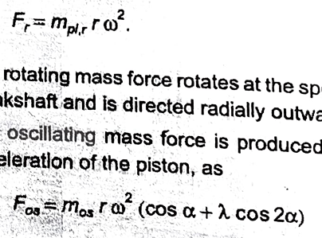The rotating mass comprise crank journal mass, compensating mass and connecting rod mass component. The oscillating masses comprise mass of piston with accessories, piston pin mass and connecting rod mass component. In the model the crankshaft is equalised so rotating mass only depends on rod mass component. The mass forces can be evaluated by formula:

Fr and Fosc represent rotational and oscillatory forces, respectively. The resultant force is obtained through vector addition. The oscillatory force has two components: 1st order (rotational frequency) and 2nd order (double rotational frequency). The rotational force can be fully eliminated with compensatory mass. However, 1st order oscillatory forces can only be partially reduced, and 2nd order forces require a special shaft that eliminates force at double crank speed.

**For multi-cylinder Engine**

In a multi-cylinder engine, compensatory masses and crankshaft configuration adjustments can eliminate mass forces. The cylinder gap causes additional moments, nullified by the correct cylinder configuration and number. A 4-cylinder engine with a symmetrical crankshaft and 180° crank offset cancels 1st order forces and moments, quadruples 2nd order forces, and nullifies the moment.

**Resonance**

Resonance occurs when the crankshaft oscillates at its natural frequency, which is the frequency at which the system vibrates when disturbed without external forces, depending on mass and stiffness. Resonance can lead to excessive vibrations due to a significant increase in amplitude and minimal damping.

# EQUIPMENT AND SPECIFICATION:

The **TM-180 model** is used to study free mass forces and moments. Below is its detailed diagram.

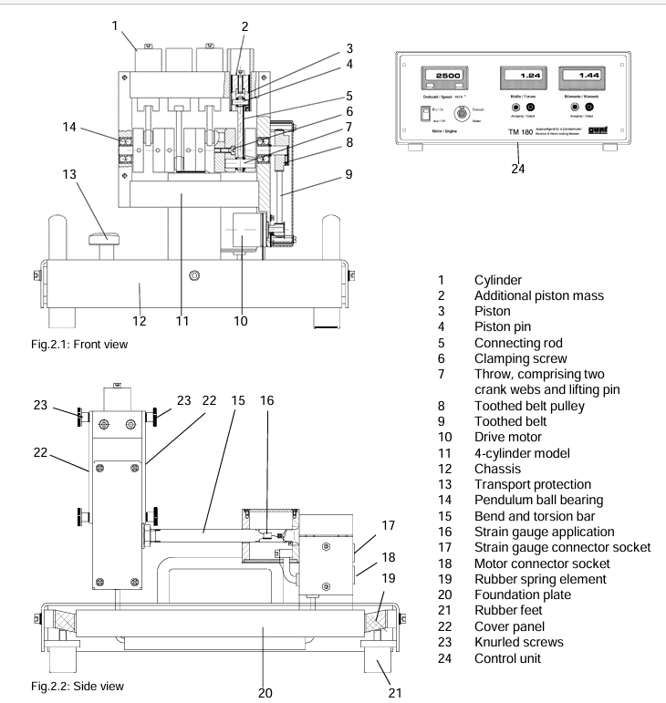

The TM-180 unit includes a 4-cylinder model, foundation plate, flexible model bearing, and control unit. The stainless-steel crankshaft has an adjustable offset and is supported by two pendulum ball bearings. Aluminium rods with needle ends are non-dismantlable at the lower end. The crankshaft throws are pressed with lifting pins and crank webs. Transparent covers protect against contact with the running crank. Powered by an external rotor with a toothed belt, the model is mounted on an elastic cantilever with a strain gauge. The bearing is on a foundation plate, flexibly suspended with rubber springs.

The **control unit**, connected by two plug-in cables, manages all electrical functions and displays.

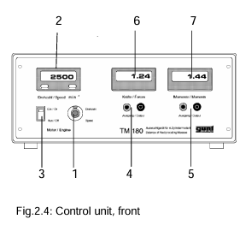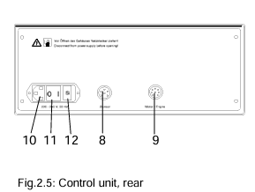

The control unit features a rotational speed controller for the brushless motor with a digital speed display. It has a switch to turn the motor on/off. Two measuring amplifiers amplify strain gauge signals, which are accessed via laboratory sockets and displayed as rectified values on a front panel digital voltmeter. The rear end includes connector sockets, the main power supply with an intel connector, the main switch, and fusing.

# OBSERVATION TABLE:

|  |  |  |  |  |  |  |  |  |  |
| --- | --- | --- | --- | --- | --- | --- | --- | --- | --- |
| **Case** | **Adjustment of the Crank** | **Frequency (Rotation per Minute(rpm))** | | | | | | | |
| **500** | | **750** | | **1000** | | **1250** | |
| **Force (N/v)** | **Moment (Nm/V)** | **Force (N/v)** | **Moment (Nm/V)** | **Force (N/v)** | **Moment (Nm/V)** | **Force (N/v)** | **Moment (Nm/V)** |
| **A** | 4-cylinder, Flat Design, Symmetric | 0.2 | 0.04 | 0.14 | 0.04 | 0.39 | 0.24 | 0.23 | 0.19 |
| **B** | 4-cylinder, Flat Design, Asymmetric | 0.22 | 0.08 | 0.22 | 0.24 | 0.56 | 0.61 | 0.41 | 0.41 |
| **C** | 4-cylinder, 3D Design, Symmetric | 0.07 | 0.09 | 0.2 | 0.3 | 0.47 | 0.74 | 0.37 | 0.46 |
| **D** | 4-cylinder, 3D Design, Asymmetric | 0.04 | 0.13 | 0.15 | 0.53 | 0.31 | 0.62 | 0.26 | 0.57 |
| **E** | 2-cylinder, 180**°** twin | 0.22 | 0.17 | 0.09 | 0.64 | 0.37 | 0.11 | 0.15 | 0.61 |
|  |  | **250** | | **500** | | **750** | | **850** | |
| **Force (N/v)** | **Moment (Nm/V)** | **Force (N/v)** | **Moment (Nm/V)** | **Force (N/v)** | **Moment (Nm/V)** | **Force (N/v)** | **Moment (Nm/V)** |
| **F** | 1 cylinder,  Parallel twin | 0.05 | 0 | 0.32 | 0.03 | 1.08 | 0.3 | 0.96 | 0.28 |

# ARRANGEMENTS:

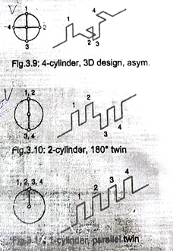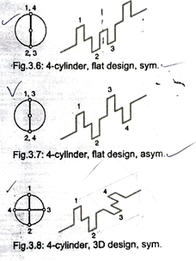

# GRAPHS:

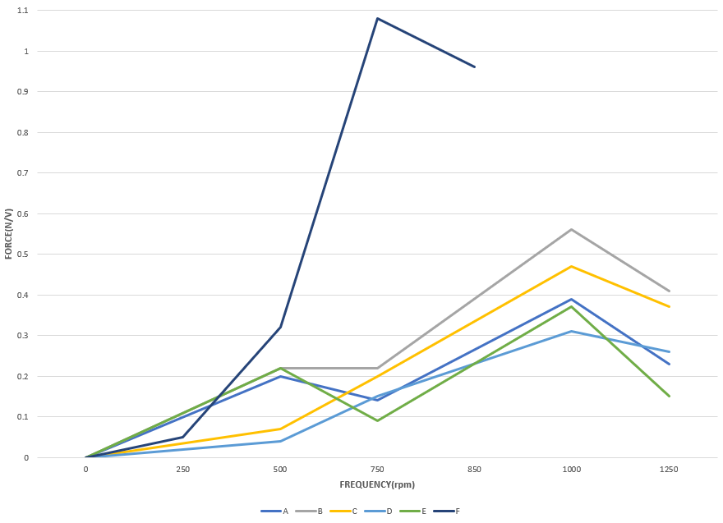

**Force measured at different configuration of TM-180 model at different frequencies**

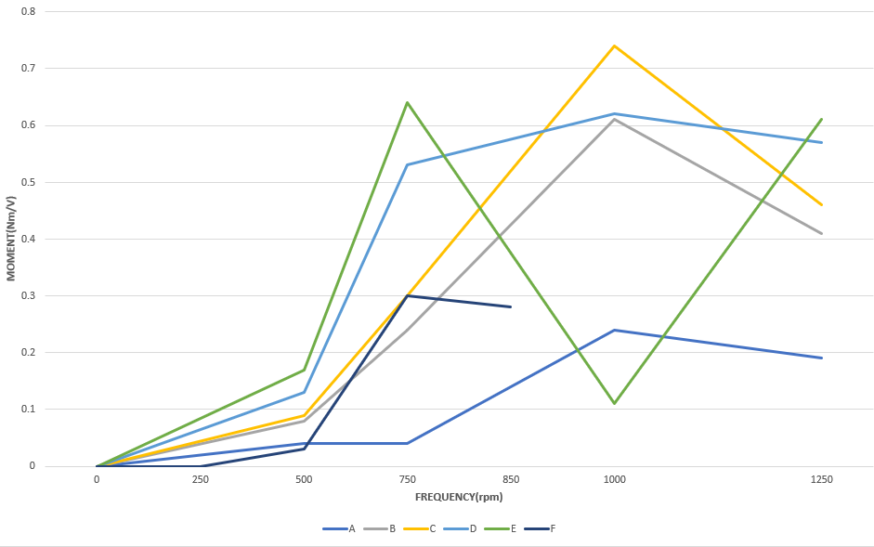

**Moment measured at different configuration of TM-180 model at different frequencies**

# COMPARISION WITH THE THEORY:

In the experiment, we operated the TM-180 model at six different configurations and observed the mass forces and moments delivered to the strain gauges in the control unit. Our observations aligned with the theory:

* When the motor started, vibrations and loud noises were observed as rotational speed increased.
* As speed continued to increase, vibrations and forces also rose up to a certain point. Beyond this point, vibrations significantly decreased. The highest vibration occurred at resonance.
* The force and moment plots varied across configurations due to partial balancing of mass force and moment components in each configuration.
* The configuration with all crankshafts arranged parallel showed maximum vibration, with the speed limited to 1000 rpm to prevent excessive wear and tear. This configuration had the worst mass force and moment balance.
* The 4-cylinder, 3D symmetric design is ideal for balancing, efficiently handling primary and secondary forces, minimizing vibration and moments, and ensuring smooth engine performance.

# CONCLUSION AND DISCUSSION:

Reciprocating engines, commonly used in industries like automotive, typically rely on a crankshaft mechanism. The TM-180 model represents a 4-cylinder engine, although real-world engines often have more cylinders with varying configurations. The engine’s primary function is converting reciprocating motion—driven by gas intake, combustion, compression, and expulsion—into rotational motion. Due to the high frequency of reciprocating motion, the resulting vibrations can significantly affect engine performance.

The experiment on balancing the reciprocating engine highlighted that precise balancing of forces and moments is crucial for reducing vibrations and improving performance. Adjusting the position and mass of counterweights neutralized first-order mass forces, minimizing their effect on the engine structure. Efforts to balance even moments successfully reduced residual forces.

The experiment also explored counterweights in mitigating rotational mass forces, emphasizing the role of materials with high first-order resonance frequencies for minimizing vibrations at higher rotational speeds. While second-order mass forces still contribute, their impact is much smaller. This careful balancing stabilized the engine, reduced component wear, and enhanced efficiency.

Expanding the experiment to engines with more cylinders would provide insights into scaling mass forces and moments, offering further opportunities to reduce vibrations. Refining counterbalance weights could further minimize residual vibrations, leading to improved engine stability and efficiency across industrial applications. Left unchecked, vibrations can lead to mechanical failure and reduced engine lifespan.

# ADDITIONAL DISCUSSION:

**Static Forces**

Static forces refer to forces that act on a body at rest or in equilibrium, with no acceleration. In advanced mechanics, static equilibrium is achieved when the sum of forces and moments acting on a body is zero. The principles of static equilibrium are governed by the equations of equilibrium: ΣF = 0 (sum of forces) and ΣM = 0 (sum of moments).

**Dynamic Forces**

Dynamic forces change with time and affect systems in motion, requiring complex analysis. Key types include inertial forces like centrifugal and Coriolis forces, dynamic loading such as impact, cyclic, and seismic loads, and vibrations that amplify during resonance. Damping reduces vibration amplitude, ensuring stability. Non-linear dynamics, analysed through FEA, involve unpredictable behaviour from deformations. Impact analysis is essential for high-magnitude forces, like in crash tests. Tools like Lagrangian mechanics, Newton's second law (F = ma), and FEA predict system responses. Understanding dynamic forces is vital in structural, mechanical, and aerospace engineering.

**Strain gauge**

Strain gauges measure strain (deformation) in materials by detecting changes in electrical resistance when the material stretches or compresses. Typically made from thin metal wire or foil arranged in a zigzag pattern, strain gauges are bonded to the test material’s surface. The gauge factor (GF) defines sensitivity, representing the ratio of the change in resistance to the change in length (strain). Strain gauges must be calibrated and are sensitive to temperature variations. Since the resistance change is small, a signal conditioning system, like a Wheatstone bridge, is used to amplify the output. Six strain gauges help assess load distribution between reciprocating and rotating masses in engines, providing accurate, reliable data for detecting and correcting imbalances.

**Crankshaft Mechanism**

The crankshaft converts the pistons' reciprocating motion into rotational motion. As the pistons move down during the power stroke, they push the connecting rods, transferring force to the crankpins, causing the crankshaft to rotate. This rotation is continuous due to the timing of the engine’s intake, compression, power, and exhaust strokes. The camshaft manages valve timing, while the crankshaft synchronizes piston movement. Crankshafts are made from high-strength steel or forged materials to handle engine stresses, with hardened surfaces to reduce wear. The crankshaft works with the camshaft through a timing gear, ensuring valves open and close at the right times. It often drives the camshaft via a timing belt or chain.